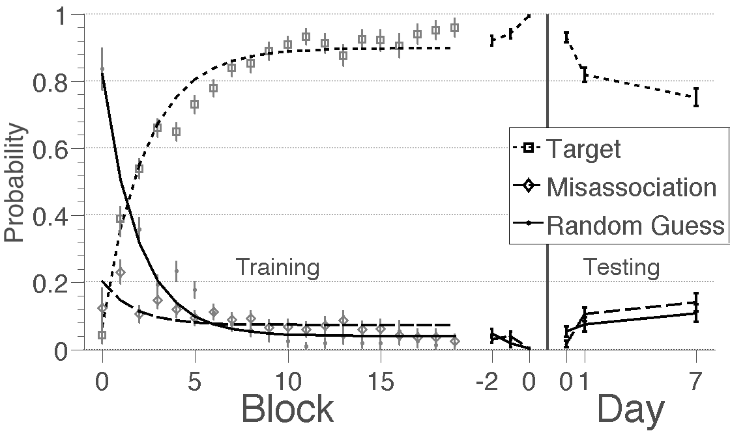
A
B
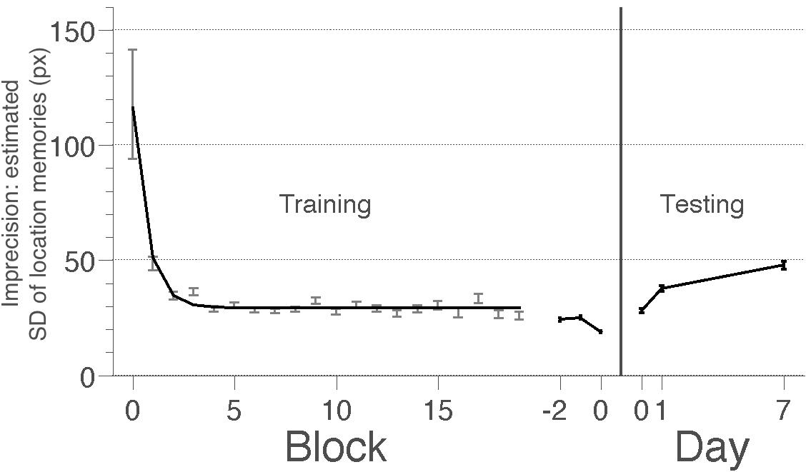
Figure 4. Estimated imprecision, misassociation and random guessing for Experiments 1 and 2. (A) The probability of selecting the target objects (dotted lines and squares), misassociation (associating an object with the wrong location; dashed lines and diamonds) and randomly guessing (solid lines and dots) during the training blocks in Experiment 1, and testing blocks in Experiment 2. In the training blocks, the points show across-subject estimates of the different response types and the lines show exponential fits to those estimates. (B) The estimated imprecision (standard deviation) of remembered locations. Consistent with subjects’ RMSE, the imprecision of locations, the probability of making misassociations and the rate of random guessing decreased during training and increased during testing. All error bars indicate posterior SD.

